# Extensive and Intesive Reading exercise Team 4

# Circle the image that represents for you, extensive reading (red color) and intensive reading (green color)

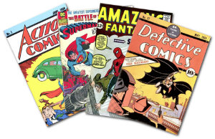

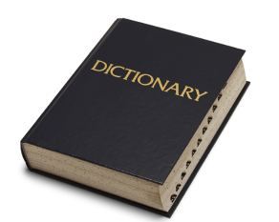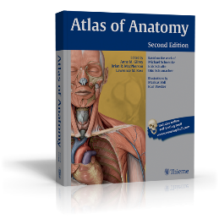

# Read the following text carefully. Write the key words from the text you used to understand the reading

Federal Firearms License Renewal Applications are sent to the mailing address on file 90 days prior to expiration. Renewals must be sent to ATF on or before the date of expiration to be considered timely. Failure to submit a timely renewal form will result in the discontinuance of the operations authorized by your current license and it will be placed “out of business.” A new Federal Firearms License Application will need to be submitted and approved to continue business. We recommend you complete the renewal upon receipt to avoid disruption in your business operations. If your application has been received timely by FFLC, you may continue operations as usual while your application is being processed.

**How do you consider the reading requires Extensive reading or intensive reading? Why?**

Because the renewal of business licenses is a subject related to some mental effort.

**What is the text about?**

Renewal of business licenses

**Write the key words from the text you used to understand the reading**

License

Expiration

Discontinuance

business operations